**Report of Task 2**

1. **Load Data and preprocessing**

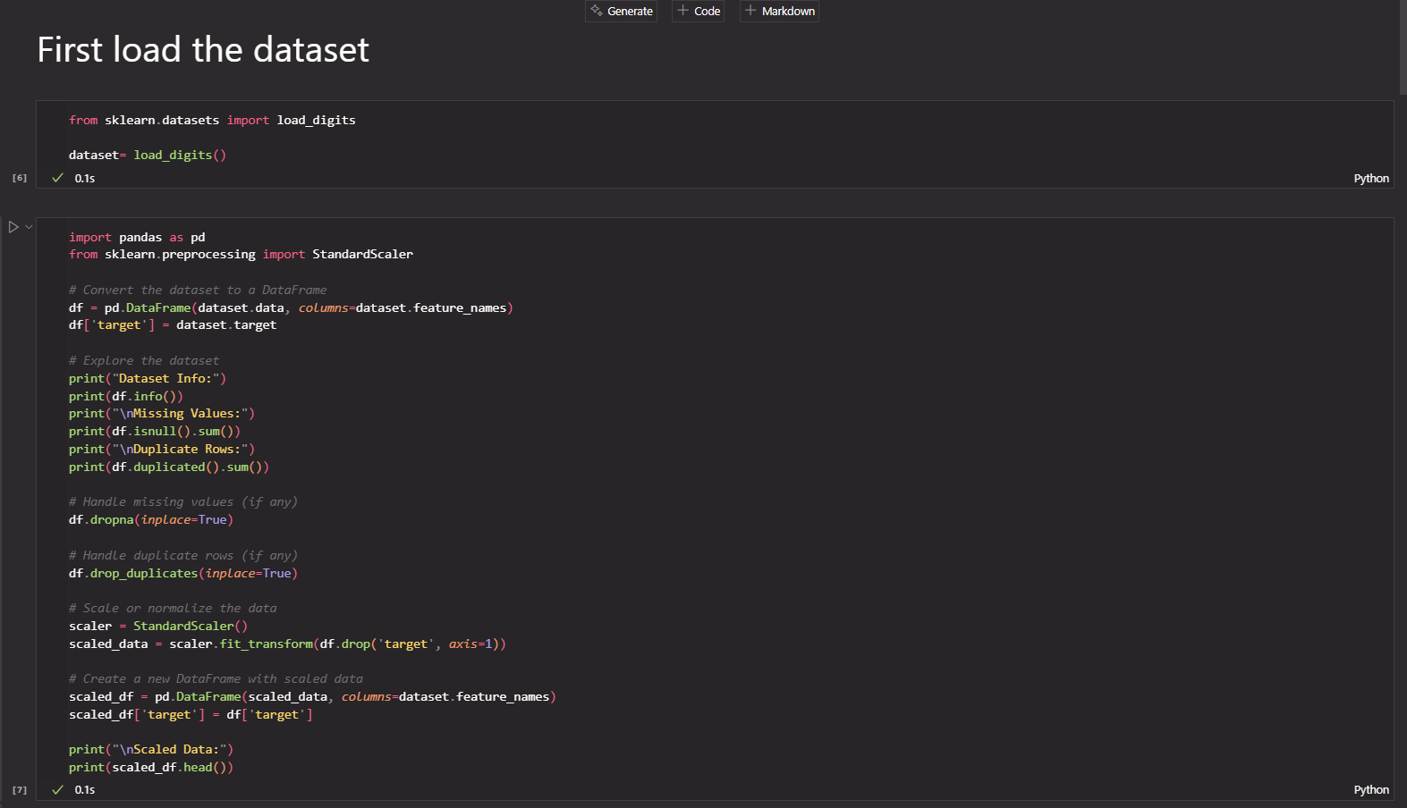

**Output:**

1. **Apply Dimensionality Reduction and Visualization**

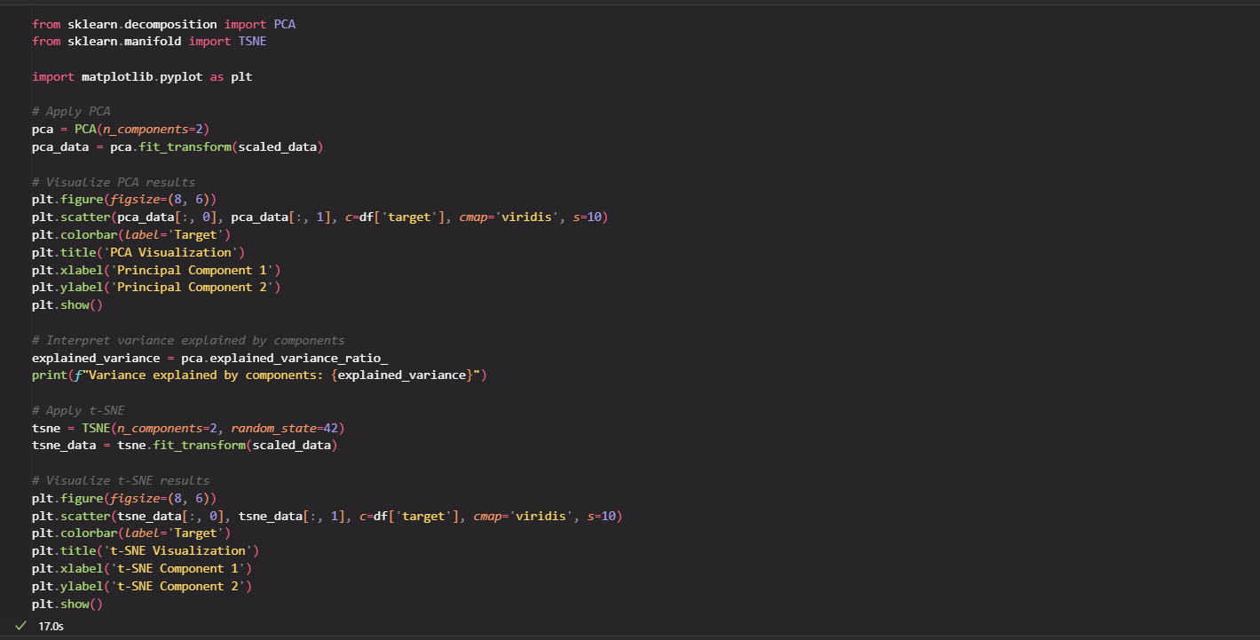

**Output:**

1. **Apply Clustering**

**Output:**

1. **Analyze the quality of clusters**

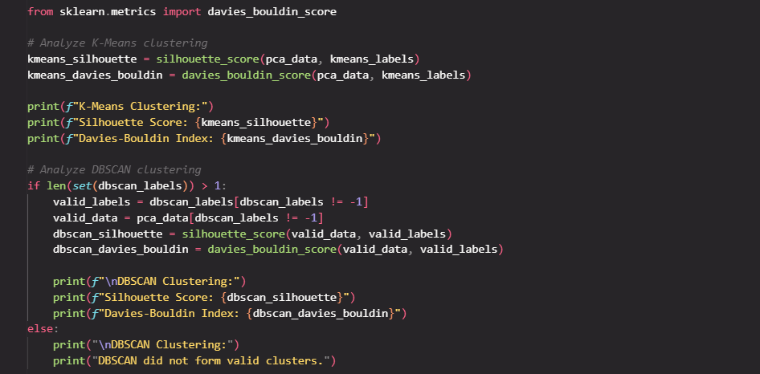

**Output:**

